**Department of Electronics and Communication Central University of Rajasthan, Ajmer**



Signal and System Lab

Subject ...................................................................................................

ECE 214

Subject Code ...................................................................................................

6

111

Experiment No. .......................................................................................

Date:- - -2024

Roll no:- 2022BTECE012

Name:- Ojasvee Satija

**Title: -** Write MATLAB code for plotting Continuous-Time Signals, Discrete-Time Signals and Sampled-Signal.

**Apparatus required:** - Downloaded MATLAB or OCTAVE software in device.

**Introduction:**-

* **Continuous Time Singal:-** A continuous-time signal may be defined as a mathematical continuous function. This function is defined continuously in the time domain. For continuous- time signals, the indepen-dent variable is time t.
* **Discrete-Time Signals :-** A discrete-time signal is defined only at certain time-instants. For discrete-time signal, the amplitude between two time instants is just not defined. For discrete-time signals, the independent variable is time n. A discrete time signal is represented by x(n) This means that to represent a discrete-time signal, we shall enclose the independent variable 'n' in brackets( ).
* **Sampled-Signal:-** A sampled signal is one in which the sampling of the signal at particular time interval.

The time period of the sampling is constant for the whole signal.

**Code:-**

**Input and output:-**

* 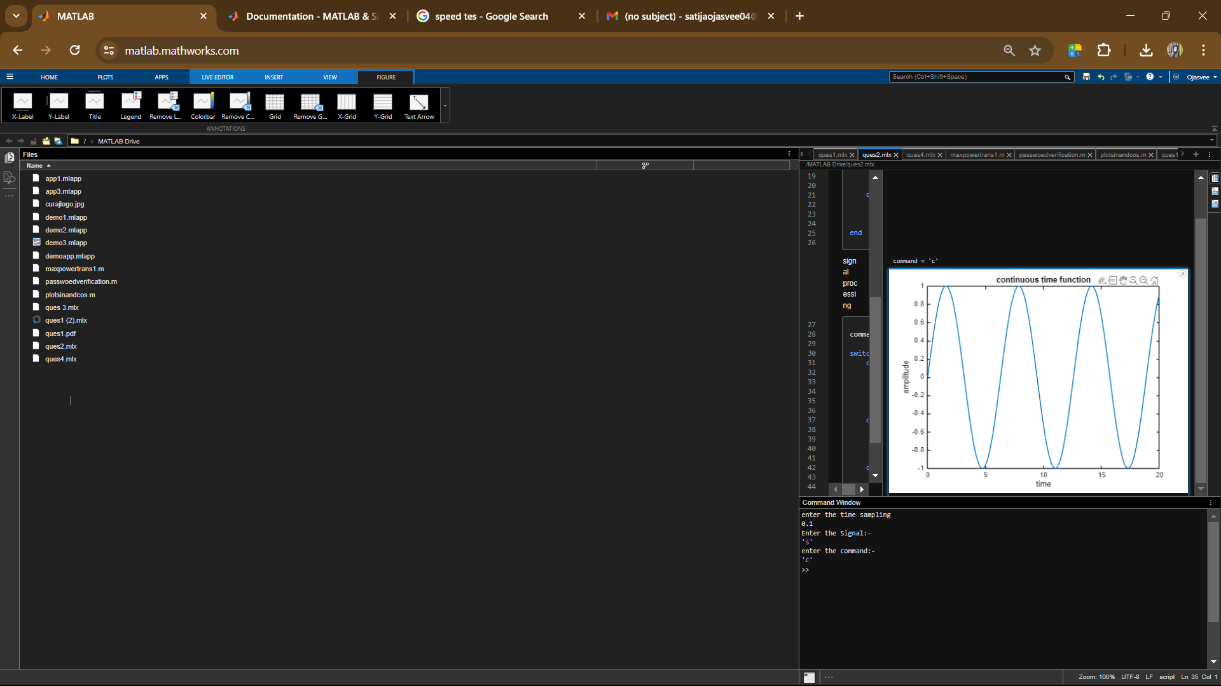
* 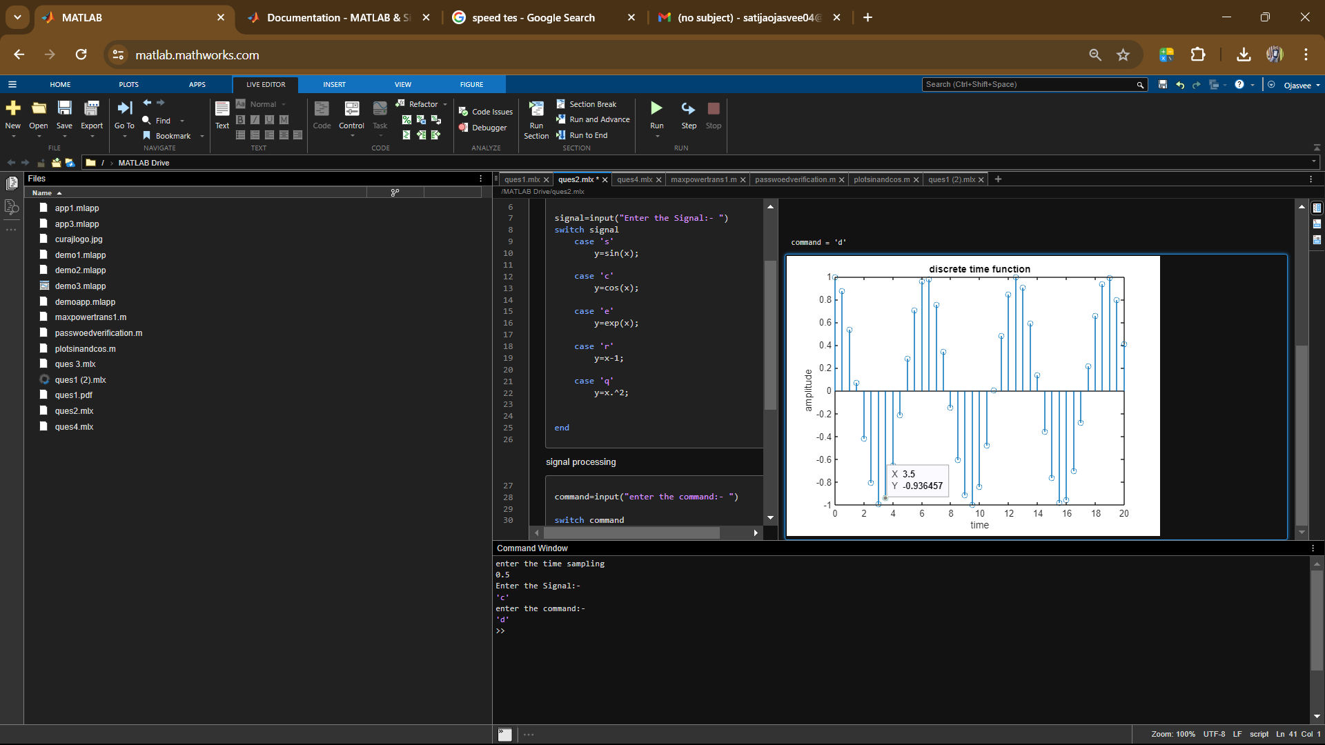
* **A screenshot of a computer

  Description automatically generated**

**Result:-** Performed the plotting of Continuous-Time Signals, Discreate-Time Signals and Sampled-Signal.